Top tips for developing/delivering workshops:
Sport has the power to provide a universal framework for learning important life skills. Integrating cricket/ physical activity is an effective way to increase participant’s ability to learn and apply new skills and knowledge.
Although the break from workshop section is optional, I want to encourage you all to make use of this section to allow you to incorporate workshops into your cricket session and to help create workshops that are effective and engaging for participants.
One way to do this is to change the name of a cricket activity or add new rules in relation to the workshop theme to help drive learning throughout. For example, if you were doing a mental health workshop you can change the cricket game name to ‘feelings cricket’. Every time a participant hits a ball, they must run to a colored cone which reflects the way they felt after that hit. For example, if they were happy with the shot, they would run to a yellow cone, if they were angry about the shot, they would run to blue cone. Be sure to make the connection of why they feel a certain way after their shot. You can be as creative as you like!

Name | Katie Holland
Programme | Wicketz
Topic | Mental Health- Understanding Feelings and Emotions
Total Time | 1 hour
Age Range | 8-12 years old
Workshop Aims:
- To increase awareness and understanding about mental health
- To help participants better understand various feelings and emotions they feel in their day-to-day life.

Resources:
- Flip Chart Paper/large bit of paper
- pens
- Coloured cones

Short Term M&E:
Evidence of learning: what questions are you going to ask at the start and end of workshop?
- Have you heard of mental health? If yes, get participants to run to the blue cone, if not get them to run to the yellow cone.

Task | Time | Description
Introduction - select and introduce a theme for your session.  Theme for the workshop:  Feelings and Emotions | 5 Minutes | Ask participants “what is mental health?”  - Mental health is how we think, feel and act. It is to do with our brain, and it is always changing.  - We all have mental health, just like we have physical health.  - When our mental health is good, we enjoy being around others and feel as if we can take on challenges. But when our mental health is not so good, we can find it much harder to cope.  There are a lot of things that can affect the way you feel (See list below on additional information sheet)  It is important we recognize and understand our emotions to help us stay on top of our mental health.
Main Workshop Activity - making sure it fits in line with your session aims.  Task Name:  Feelings Relays | 15 Minutes | - Split groups into teams.  - Place flip chart paper at one end of the hall with a pen and a cone at the other end.  - Give some examples of emotions to help participants get started.  - Relay- each team must run as fast as they can to write as many emotions as they can in 5 minutes.  - Participants must go one at a time and only write one emotion each go.  - If they are struggling to think of some, encourage them to work together as a team.  After 5 minutes, read out some examples that the young people have written. Ask the group to go back into their groups and then to write down examples of how people may react to certain emotions. Some examples to help guide the group:  "If you are sad, you might stay away from friends."  "If you are angry, you stomp your feet."  “If you are happy, you could have a smile on your face”.  “if you are nervous, you may get butterflies in your tummy”  Key point to make:  We all have good and bad days, but when negative thoughts and feelings start to affect your daily life and stop you doing things you enjoy, this probably means you need some support with your mental health.  Example: if someone is feeling anxious all the time and its affecting them sleeping, socialising etc this could be a sign they would benefit from getting help.  Places to go for help:  Family, Friends, Teacher, Coaches  Ring HOPELINEUK on 0800 068 4141 or the Samaritans on 116 123.  Text SHOUT to Shout's textline on 85258.
Optional but great to utilise.  Physical Activity - this section is designed to keep engagement and improve learning. Continue reiterating workshop points throughout a physical activity of your choice (see top tip at the bottom for an example).  Task Name:  Emotions cricket | 30 minutes | Continuous cricket turns into emotions cricket …  Set up various cones close to the wicket, making sure you use different colours.  Every time a batter goes to hit the ball, they must run to the cone that represents how they are feeling after they’ve taken the shot. For example, yellow is happy, green is proud, blue is sad and white is another feeling.  Once the ball is back to the bowler, the batter (if comfortable) tells the group/coach why he went to that coloured cone. For example, they may say ‘ I felt proud of that shot because I hit a 6’ or ‘I felt angry because I missed the ball’.  You can also randomly ask the fielders how they are feeling throughout play. This allows young people to better understand why they feel certain emotions.
Round up of workshop - making sure to ask the same question as you did at the start to see what learning has taken place. | 5 | What is mental health?  Have you learnt anything today?  Did you enjoy the workshop?  Is there anything you would like to learn next time about mental health?

Additional Resources:
There are lots of reasons why we might start struggling with our mental health.
These can include:Problems at home, school, or in your relationships and friendships
- Losing someone important to you
- Confusion about who you are, your sexuality or beliefs.
- Big events or changes in your life
- Pressure from yourself or others
- Feeling lonely or like nobody understands you.
- Feeling unwell
- Being bullied
- Being abused
- Worrying about what's happening in the world or on the news.
- Worrying about things you see on social media.
- Experiencing something traumatic or frightening
Life affects us all differently. No one is the same. That’s why the right mental health support will look different to different people. What works for one person might not work the same for you, and that’s ok.
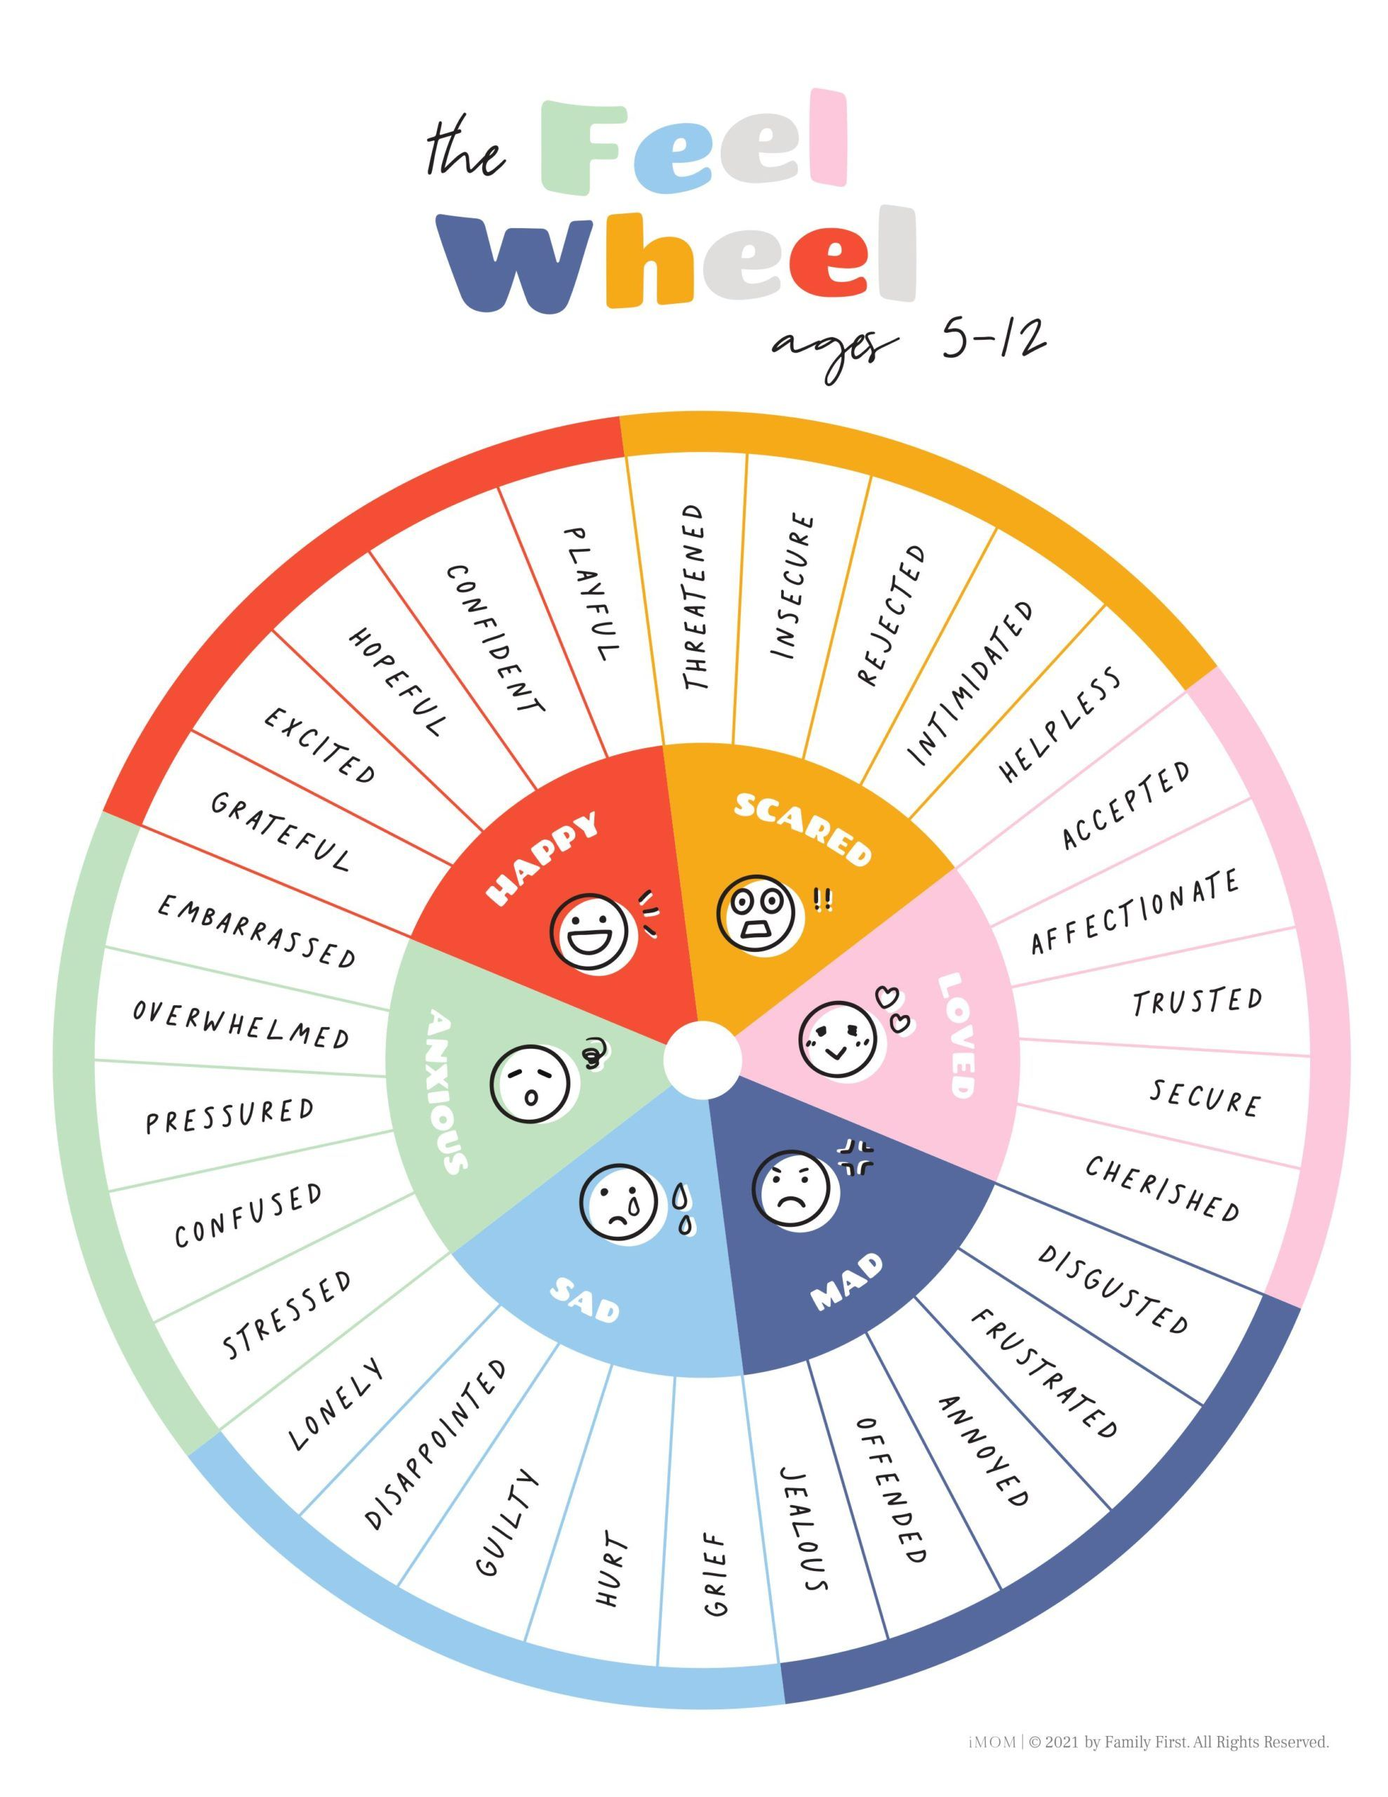

Feelings wheel to help show some examples to participants.

If you are in blue, light blue, green or orange section for long periods of time, it is a sign your mental health is being impacted.

P
Mental Health support for young people:

Kooth
kooth.com
Safe, anonymous online community and counselling for young people. Check on the website if it's available in your area.

Local Minds
mind.org.uk/about-us/local-minds
Local mental health services across England and Wales. Offers talking therapies, peer support and advocacy. Check to see if there is a Local Mind near you and what it can offer young people.

Mencap
0808 808 1111 (Learning Disability Helpline)
mencap.org.uk
Information and advice for people with a learning disability, their families and carers. Services include an online community.

The Mix
0808 808 4994
85258 (crisis messenger service, text THEMIX)
themix.org.uk
Support and advice for people under 25, offering these services:
- Helpline
- Crisis messenger textline
- Discussion board
- Webchat
- Short-term counselling by phone and online

NHS Every Mind Matters
nhs.uk/every-mind-matters/mental-wellbeing-tips/youth-mental-health
Information and advice on mental health and wellbeing for young people. Includes videos about dealing with change, social media and sleep.

NHS Go
nhsgo.uk
Confidential health advice and support for people from 16 to 25. Includes information on mental and physical health, plus topics like relationships and sleep.

Our Time
ourtime.org.uk
Information and workshops for children and young people whose parents or carers experience mental health problems.

Reading Well
reading-well.org.uk/resources/young-people
Self-help books to help people understand and manage their mental health and wellbeing. Also available in Welsh.

Samaritans
116 123
0808 164 0123 (Welsh Language Line)
jo@samaritans.org
samaritans.org
Samaritans are open 24/7 for people to talk about any concerns, worries and troubles they’re going through. You can visit some Samaritans branches in person.

YoungMinds
youngminds.org.uk
Mental health support for young people, parents and carers. Includes information about mental health problems and medication.

