Top tips for developing/delivering workshops:
Sport has the power to provide a universal framework for learning important life skills. Integrating cricket/ physical activity is an effective way to increase participants ability to learn and apply new skills and knowledge.
Although the break from workshop section is optional, I want to encourage you all to make use of this section to help create workshops that are effective and engaging for participants.
One way to do this is to change the name of a cricket activity or add new rules in relation to the workshop topic to help drive learning throughout. For example, if the workshop was on cyber safety every time someone hits the ball, they must shout one way to stay safe online. Every time, someone gets someone out, they state an organisation/person they can contact If they feel unsafe online.

Name
Programme | Wicketz
Topic | Winning and losing- controlling emotions- session 1
Total Time | 20 activity, 45 minutes cricket activity
Age Range | 8-16
Workshop Aims:
- To introduce the block of wellbeing sessions around channelling anger and frustration effectively.
- Introduce the emotions word cloud.
- To recognise positive and negative examples of reactions to winning and losing.

Resources:
- Laptop
- Pens
- Sheets with 3 different reaction pictures on it (see below)
- World cloud

Short Term M&E:
Evidence of learning: what questions are you going to ask at the start and end of workshop?
- Has anyone heard of the emotions word cloud?
- Does anyone know how to channel their anger and frustrations in an effective way?

Task | Time | Description
Introduction - select and introduce a theme for your session. | 3 | Who, what, where & why?  Devon Conway at the T20 world cup  - Missed out on the final because of his actions  Explain what the word cloud is  Set the scene around…  The person  The action  The consequence
Main Workshop Activity - making sure it fits in line with your session aims. | 15 | Activity 1: 3 different images of players reacting to winning and losing (poor, good, grey area)  Identify the positives and negatives in both pictures  Consider the consequences (in a game, opposition players, your own teammates).  Encourage them to think about actions others, there is a fine line between passion and poor conduct.  Activity 2: Think about examples when we have reacted positively and negatively in…  Cricket environment  School environment  Home environment  Reflect on what has already been discussed, and apply to own experiences and how we can improve the way we react to adverse scenarios
Optional but great to utilise.  Physical Activity - this section is designed to keep engagement and improve learning. Continue reiterating workshop points throughout a physical activity of your choice (see top tip at the bottom for an example) | 40 | Cricket game of your choice. Monitor their behaviour throughout and tally up any behaviour that becomes poor conduct.
Round up of workshop - making sure to ask the same question as you did at the start to see what learning has taken place. | 2 | Ask same question as you did at the start. Encourage them to continue thinking about their behaviour outside in and outside of cricket.

Additional resources:

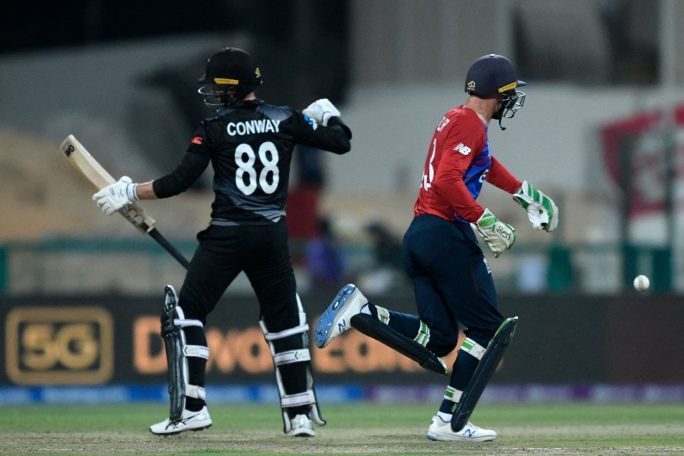
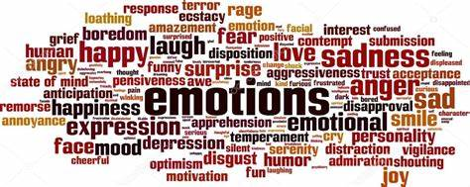

Devon Conway in the T20 World Cup 2021
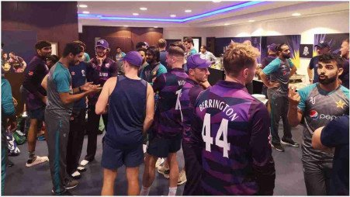
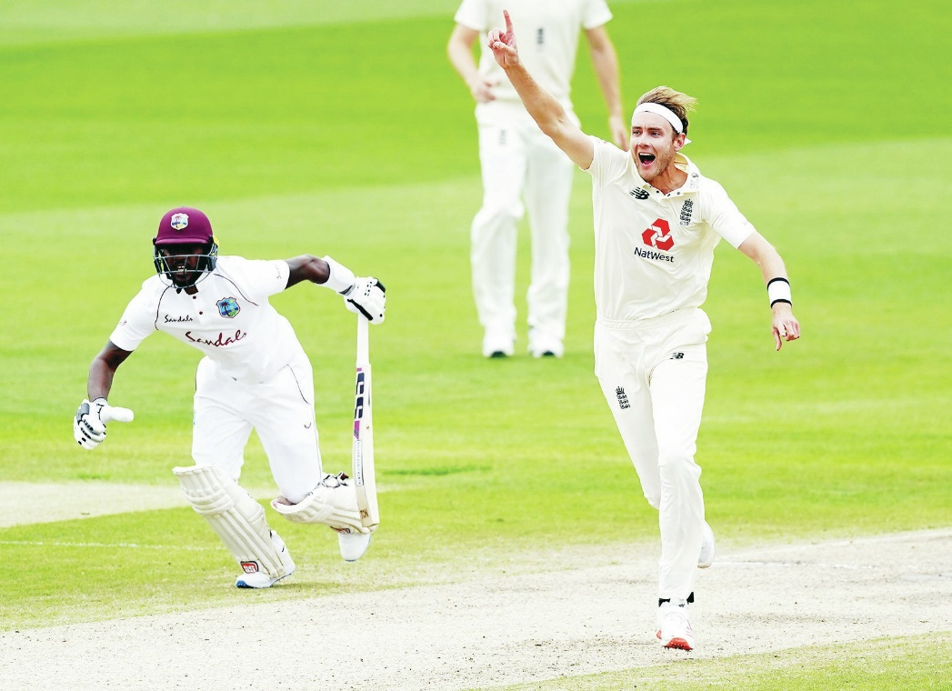
Team Pakistan and Team Scotland at Haris Rauf’s birthday party, after Scotland lost every single game they played in the T20 World Cup 2021

Stuart Broad with one of his famous ‘celebrappeals’ against the West Indies

