**Place numbers in the yellow boxes to correctly order the steps of performing CPR on an unresponsive casualty who is not breathing normally.**

CPR (COVID – 19 version)

Activity A15

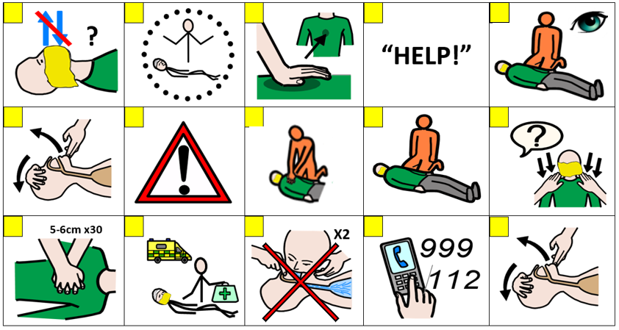

**At this time please do not put your face next to theirs to check for breathing, instead only look carefully for the chest rising and falling. When giving CPR place a cloth over the face of the casualty**