Top tips for developing/delivering workshops:
Sport has the power to provide a universal framework for learning important life skills. Integrating cricket/ physical activity is an effective way to increase participants ability to learn and apply new skills and knowledge.
Although the break from workshop section is optional, I want to encourage you all to make use of this section to help create workshops that are effective and engaging for participants.
One way to do this is to change the name of a cricket activity or add new rules in relation to the workshop to help drive learning throughout. For example, if the workshop was on cyber safety, every time someone hits the ball, they must shout one way to stay safe online. Every time a participant catches someone out, they state an organisation/person they can contact If they feel unsafe online.

Name
Programme | Southampton Wicketz – SMLC Girls Hub
Topic | Rubbish – learning what is recycling and what is household waste
Total Time | 30 minutes
Age Range | 8-12
Workshop Aims:
- To know the different type of bins we use to dispose rubbish at home.
- To know the difference between household waste and recycling.
- To use information on packaging to put things into the correct bins.
Resources:
- Bins
- Rubbish
- Bin signs (household waste & recycling)
- Southampton City Council waste management information

Short Term M&E:
Evidence of learning: what questions are you going to ask at the start and end of workshop?
- Start and end with participants picking between 3 cones, red – not confident with knowledge of the correct bins to put rubbish in, yellow – some idea of correct bins to put rubbish in, green – confident with knowledge of the correct bins to put rubbish in.

Task | Time | Description
Introduction - select and introduce a theme for your session. | 4 mins | Participants pick from 3 cones to tell us how much confidence they have in their knowledge of sorting rubbish into the correct bins.  Red – not much knowledge  Yellow – some knowledge  Green – good knowledge
Main Workshop Activity - making sure it fits in line with your session aims. | 5 mins  10 mins | 2 teams, big pile of mixed rubbish in the middle of the hall. Race to see how many pieces of rubbish each team can run and collect in a time limit.  Within teams – separate rubbish collected into household waste and recycling piles. (Understanding what information we can look at on packaging to help us make the right decision).
Optional but great to utilise.  Physical Activity - this section is designed to keep engagement and improve learning. Continue reiterating workshop points throughout a physical activity of your choice (see top tip at the top for an example). | 5 mins | Using the separating the teams have done and in a race against the other team – run and put the pieces of rubbish in the correct bin at the end of the hall (household waste or recycling). Participants only allowed to carry 1 piece of rubbish at a time.
Round up of workshop - making sure to ask the same question as you did at the start to see what learning has taken place. | 6 mins | Participants pick from 3 cones to tell us how much confidence they have in their knowledge of sorting rubbish into the correct bins.  Red – not much knowledge  Yellow – some knowledge  Green – good knowledge
Key words:
- Recycling
- Household waste

Resources:

Bins (southampton.gov.uk)

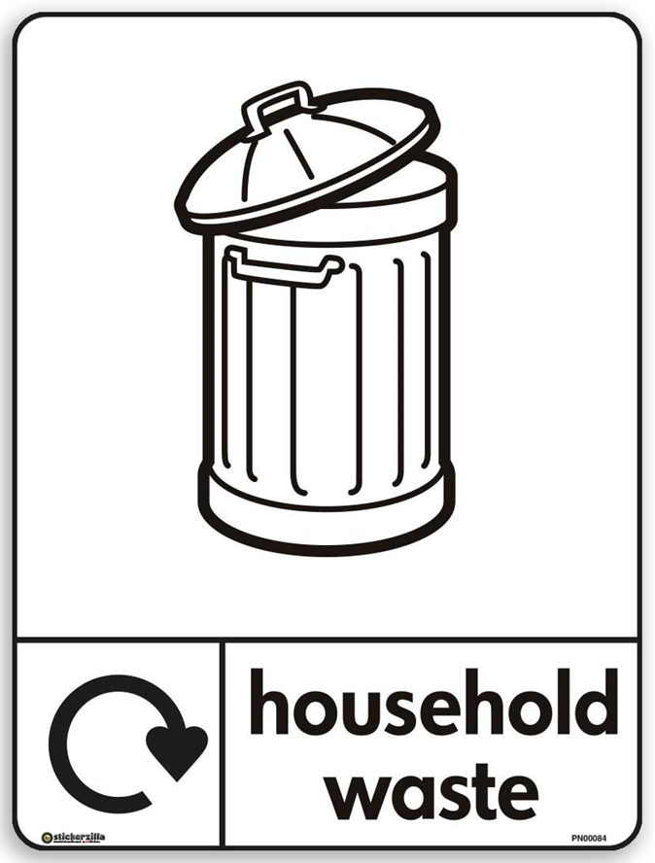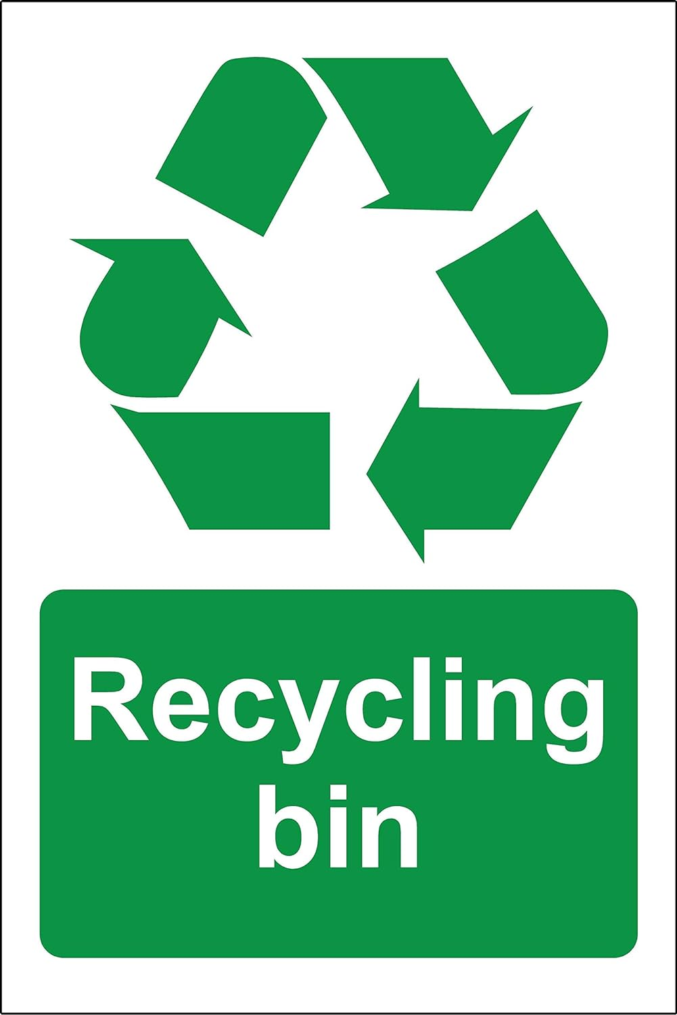

Action Shots:

