Super 1s Road Awareness and promoting the use of public transport.

Area Covered: Employability/ personal growth, Health and Wellbeing, Local Issues |  | Topic Covered: To make the participants Road Safe Aware and promote the use of public transport. |  | Intended outcome: To raise awareness on the topic and try to influence positive change of participants choices.
Session Plan:

Time: | Description: |  | Resources: |  | Key points/ Vocabulary: | How do we measure impact?
5-10 minutes (Depending on session duration) | Workshop 1: Crossing the Road  -The participants will be moving around the hall. When you hold the coloured cone up they need to do the command (Red= Stop, Orange= Jog on the spot, Green= move)  -Understand the importance of knowing traffic light signals.  -Line the participants up in 2 groups  -In pairs you need to make some catches (these act like cars)  -1 group at a time need to try and walk from one side to the other to avoid the ‘cars’  -once completed the next group get the opportunity.  -Discuss the importance of stop, look and listen. Talk about crossing at safe places  Workshop 2: Public Transport  -Split the group into smaller groups. In these groups they must work out how to get from ‘A’ to ‘B’  -You will give the group a task (Get from Red to Yellow) The cones act as ‘stops on a bus route’  -Discuss how this works, how is this like a bus/ train route, discuss any fears participants may have using this in future.  -Place different Items at the last stops (to replicate a shopping trip). Ask the group to plan the route (go from the Stumps to the Cricket ball to collect a bib and then take that to the cricket bat)  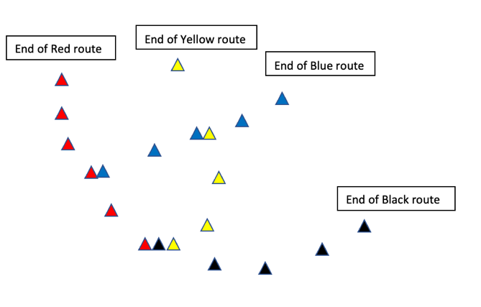 |  | Cones (Red Orange and Green). Tennis balls (1 per pair)  Cones (Different colours for different lines) cricket equipment (to act as bus stops) |  | Red, Amber, Green, Stop, Go, Get Ready, Cars, Stations, Routes. | Use of questioning to gauge understanding participant feedback to ensure correct learning.
Session Analysis: Coach feedback required.
Has the session been a success? How?
How can we measure this next week? How can we measure this in a months time? Have the participants adopted the new methods?
Step 1-Identifying themes: Do we know how a traffic light system works? When is it safe to cross a road? Can we understand a Bus/ Train map?
Step 2-SMART objectives: To increase awareness of how to cross a road effectively and to feel comfortable using public transport.
Step 3- Impact
Target Audience? Everyone in the session. People who haven’t used public transport alone.
Where?-In sessions
Delivery-Use of questions and recapping either side of an engaging, practical activity that involves cricket skills.
When?-During weekly Super 1s hub sessions
Expectation- For players to be able to relate the cricket game to a real-life scenario.
Cost to run Workshop- Free
Step 4-Super 1s coach to capture data, oversee the activity and evaluate. (Who was in the session, stand out engagement, who will adopt change (Coach to complete and feedback)
Step 5-Review: (Medium Term: did they adopt the outcomes. Long Term: are they continuing to use this in 3 weeks’ time).
Goals of session:
Short-term (Next week): Has anyone used public transport? Do we know how to affectively cross the road?
Long-term(3 weeks time): Are people travelling to the sessions on PT, are people regularly crossing the road on their own.

