LGBT Awareness Student Worksheet
Name: ___________________________

It is important that we know and use language correctly

Task 1 - Match the words with the correct definition

1. First, read the words in the boxes below.

Homosexual | Heterosexual | Gay | Lesbian | Bisexual | Sexual orientation

Transgender | Discrimination | Homophobia | LGBT | Coming out
 | 1

2. Read through the definitions below and then write the number of the correct definition that matches each word above in the boxes for each word.

1. Treating a group of people less favourably than others because of a certain characteristic. | 2. People who are attracted to the same sex. | 3. Someone who feels the sex they were born into does not match how they feel inside. This is different to sexual orientation/sexuality. | 4. An abbreviation for lesbian, gay, bisexual and trans.
5. Describes who we are attracted to. Sometimes referred to as ‘sexuality’. | 6. A woman who is sexually attracted to other women. | 7. People who are attracted to the opposite sex. Commonly known as ‘straight’. | 8. The process of a lesbian, gay or bisexual person telling others their sexuality. Can be an ongoing process.
9. Usually used to describe someone who is attracted to the same sex. It can apply to both men and women. | 10. People who are attracted to people of both sexes. | 11. A fear, hatred or dislike of people who are attracted to the same sex. Normally expressed through prejudice or discrimination towards gay people.

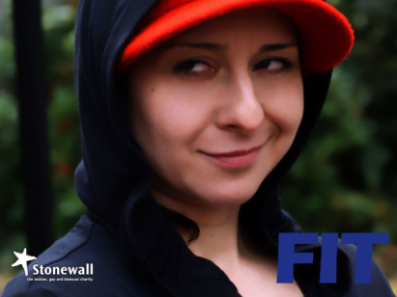


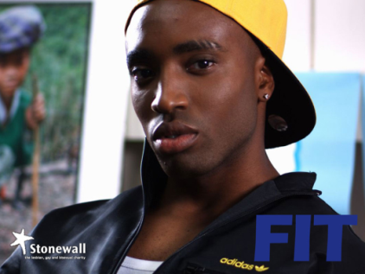

Task 2 – Straight, gay or bisexual?
Straight, Gay or Bisexual?
For each character guess whether they are straight, gay or bisexual and explain your reason why.

Isaac:
Lee:
Ryan:
Tegs:
Jordan:
Karmel:
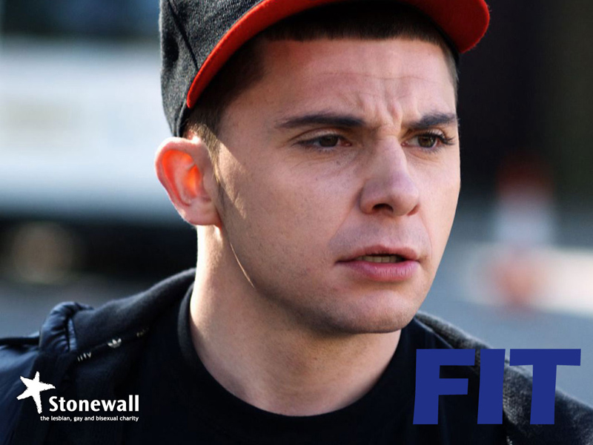
Name: Isaac
Age: 18
Hobbies: Rollerblading, Playstation, collecting baseball caps, street dance, hip hop and ragga music
Name: Lee
Age: 17
Hobbies: Basketball, street dance, graffiti art, Joelly D the pop star, karaoke
Name: Ryan
Age: 18
Hobbies: Football, martial arts, RnB, singing, Playstation,
Sci-fi, street dance
Name: Tegs
Age: 17
Hobbies: Reading, online gaming, indie music, street dance, tap dancing
Name: Jordan
Age: 17
Hobbies: football, MCing, street
dance, boxing
Name: Karmel
Age: 17
Hobbies: fashion, shopping, beauty,
drama, street dance

Lee and Karmel’s stories

If you think Lee is gay, this might be due to gender stereotyping.

Gender Stereotyping is when people assume how a person should behave or act based on their gender (male/female).

Task 3 – Add to your table as many gender stereotypes as you can.

Male Stereotypes | Female Stereotypes
e.g. should like football | e.g. should like the colour pink

Discussion Points

What have Lee and Karmel’s stories taught us about gender stereotyping?

What would you do if you found out your best friend was gay or bisexual?

Why is it important not to make assumptions about people and/or their sexuality?Student worksheet

Task 4 - Imagine you are Karmel.

Complete the table below showing the problems she is having which may be making it difficult for her to come out. Suggest a solution to each problem you see.

Problems | Solutions
1. She is finding it hard because people at school casually use the word gay in a negative way | 1. Suggest that the school introduces a strong policy against the use of homophobic language with strict punishments

Karmel’s Diary might help you…

Dear Diary,

Yet another rubbish day at college. I just don’t think I can handle more of the same. It’s all I can think about, being gay that is... I just don’t know if there is a way out. I can’t get my head straight, I can’t concentrate. My work is terrible and if I don’t get things together I’m going to seriously mess up college.

I want to tell someone…I need to tell someone…but there’s no one there to tell. I can’t talk to mum or dad, I mean imagine what would happen if I told them….what’s the point…but I hate lying. That’s what I feel I am doing – lying. I want to tell my mates, but I can’t do that either. They’d hate me. They wouldn’t understand. They always make fun of people…I don’t want to become one of those.

It’s always ‘gay’ this, ‘gay’ that…they don’t realise that every time they say that it makes me feel worse and I just can’t handle it anymore. And the word lesbian…I hate it! It sounds so sleazy and nasty. But that’s what I am.

The way I see it the only option is to block it out…being gay I mean. Is that possible?? I can only try. And if it makes things worse well…actually. Can it make things worse??

Karmel x

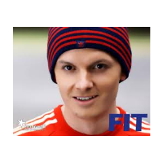
Task 6 – Questions about Tegs (group or individual)

1. What different forms of bullying is Tegs experiencing?

2. Why do you think he is being bullied?

3. How do you think Tegs is feeling about himself?

4. How can Tegs challenge the bullying he is experiencing?

5. What should be done by the school or anyone else to stop the bullying?

Task 7 - What helps to raise our self-esteem?

Around each picture, note down things that help to raise your self-esteem or things that lower your self-esteem.

Focus on feelings and emotions rather than material things. So, for example, ‘When I am treated with respect by my friends’ raises self-esteem.
Things that raise my self esteem
Things that lower my self esteem

