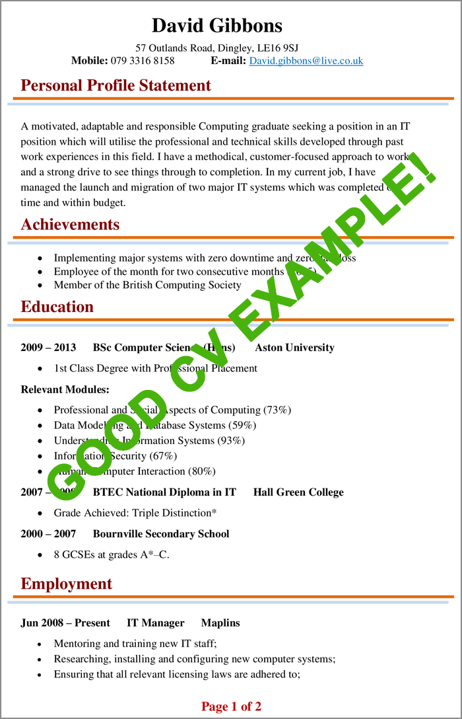

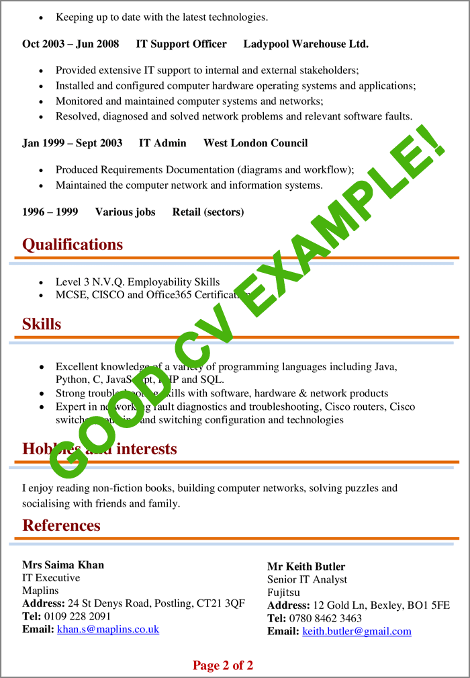
What makes this CV effective?
- It has a great format and layout, making it easier to read.
- Bullet points and short sentences and appropriately used.
- The CV is fully tailored to the job the candidate is applying for.
- A minimal amount of colour and design is used to improve the CV’s presentation and visual appeal.
- It includes all the information a standard CV should contain.
- The same format for dates is used throughout the sections.

