DESERT ISLAND SURVIVAL GAME

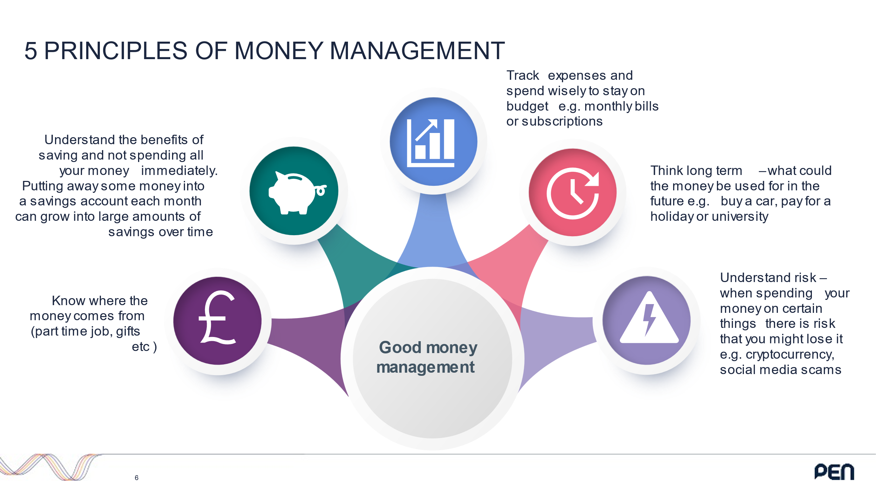You are all on your way to a summer holiday in the Caribbean, unfortunately your plane crashes on a large desert island but you luckily survive. The island is beautiful with temperatures alternating between -6 degrees and 40 degrees and occasional tropical storms. There are trees and plants on the island with drinking water available, but it is not known whether there are any dangerous animals. It is not clear if there are any survivors other than yourself and it takes two weeks on average for rescuers to arrive. The only certainty is the mysterious shop in front of you and the £100 in your pocket which you will need to use to survive the next two weeks. Whilst waiting for others to come rescue you certain things might happen to you. You need to prepare yourself for these scenarios, if you are unable to deal with the scenario you will lose either money or an item. The team which survives the best wins!

* Choose your team name

Round 1 Budgeting:

Decide how you would spend the money in order to best survive. What is the bare minimum we need to survive? Consider warmth, shelter and food.

|  |  |  |  |  |
| --- | --- | --- | --- | --- |
| Item of spending | Original Price | Round 1 Purchase or loss | Round 2 New Purchase or loss | Round 3 New Purchase or loss |
| Blanket | 15 |  |  |  |
| Plastic container | 15 |  |  |  |
| Metal cooking pot | 15 |  |  |  |
| Food parcel | 15 |  |  |  |
| Pillow | 10 |  |  |  |
| Fishing net | 15 |  |  |  |
| Fishing rod | 25 |  |  |  |
| Suncream | 10 |  |  |  |
| Toilet paper (per roll) | 5 |  |  |  |
| Chocolate | 5 |  |  |  |
| First aid kit | 15 |  |  |  |
| Toothbrush | 5 |  |  |  |
| Knife | 25 |  |  |  |
| Solar powered torch | 10 |  |  |  |
| Rope | 10 |  |  |  |
| Remaining money out of £100 |  |  |  |  |
| Team total value (original item cost + money remaining) |  |  |  |  |

Round 1 Notes:

Round 2 Notes:

Round 3 Notes: